Problem:1
Write a program to enter the length, and breadth of a rectangle and find its perimeter
and area.

#include<stdio.h>
main()

{int l,b,perimeter;
printf("ID:23103406\n");
l=20;
b=10;
perimeter=2*(l+b);
printf("perimeter is:%d",perimeter);}

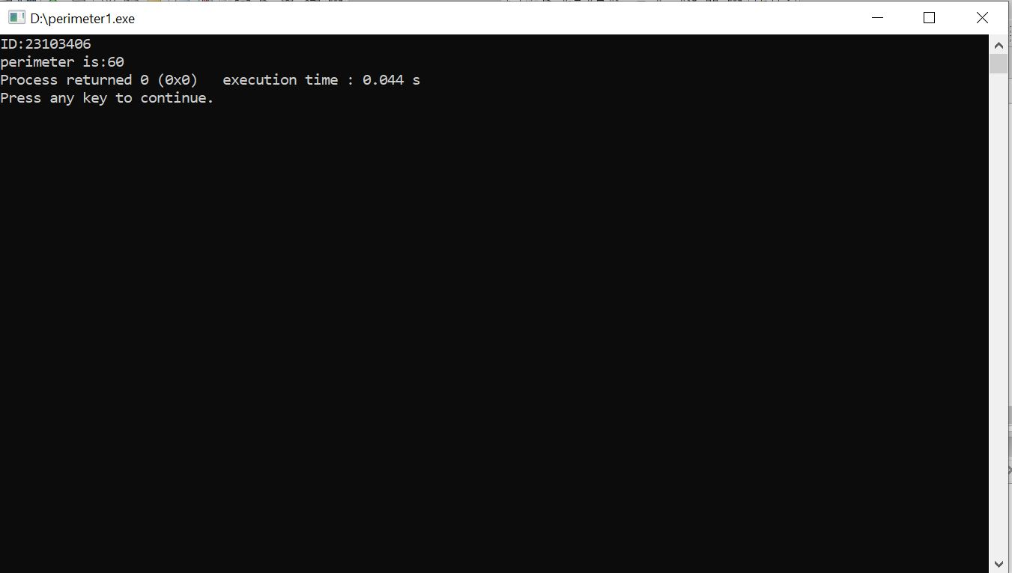

Problem:2
Write a program to calculate the perimeter and area of a circle with a given radius. Declear Pi as constant.

#include<stdio.h>
#include<math.h>
#define Pi 3.1416

main()
{float r,area,perimeter;
printf("ID:23103406\n");

r=5;
area=Pi*pow(r,2);
perimeter=2*Pi*r;
printf("area is:%f\nperimeter is:%f\n",area,perimeter);
}

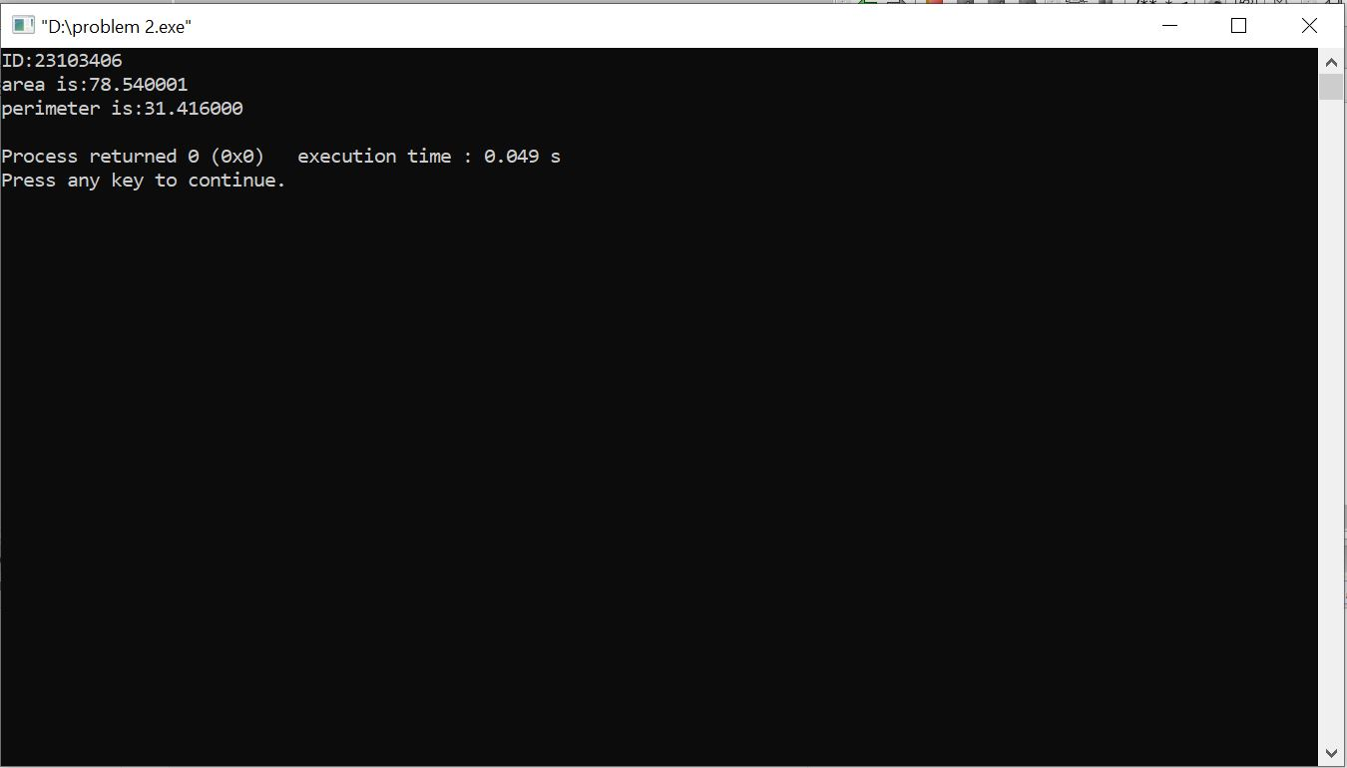
Problem:3
. Write a program to find the third angle of a triangle if two angles are given.

#include<stdio.h>
main()
{int a1,a2,a3;
printf("ID:23103406\n");
printf("a1:");
scanf("%d",&a1);
printf("a2:");
scanf("%d",&a2);
a3=180-(a1+a2);
printf("so the third angle a3 is=%d\n",a3);}

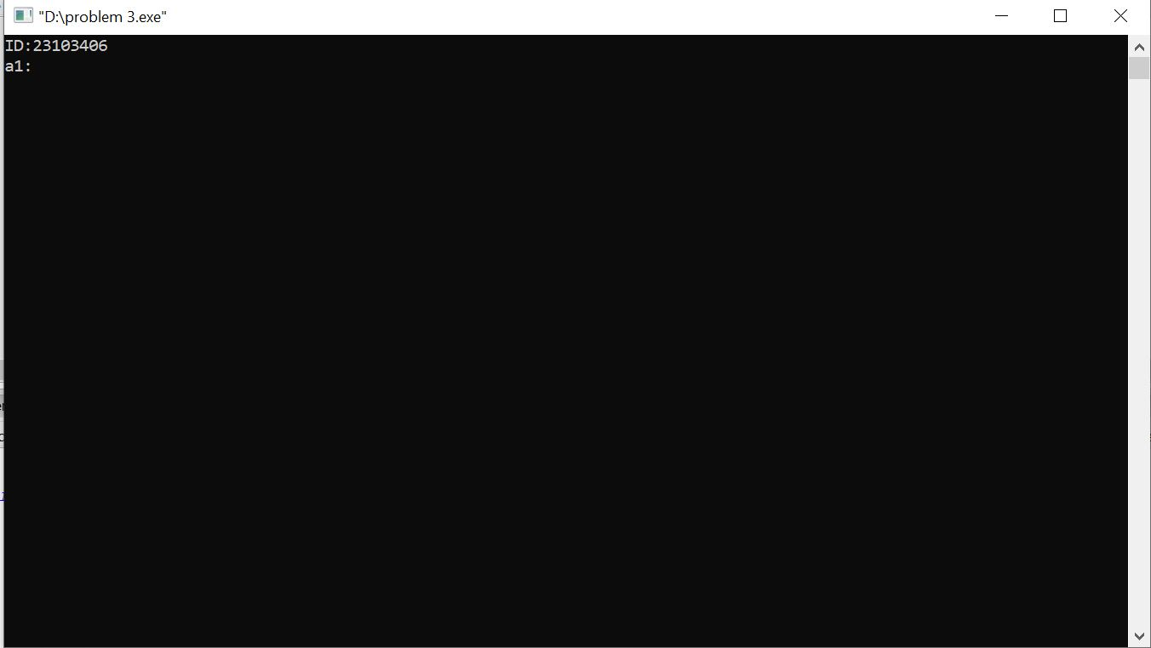

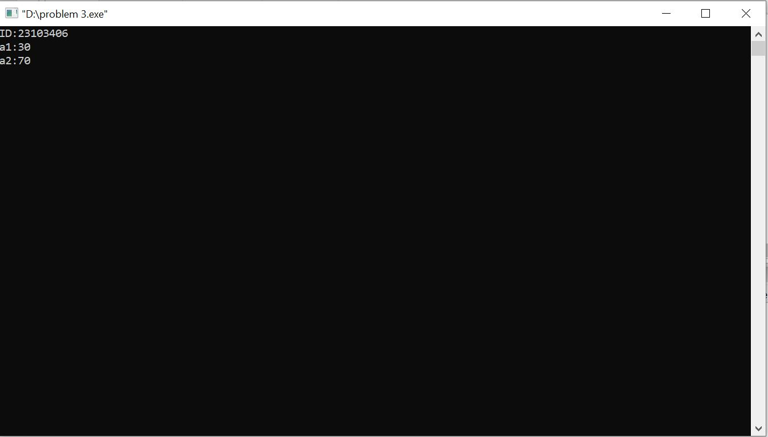
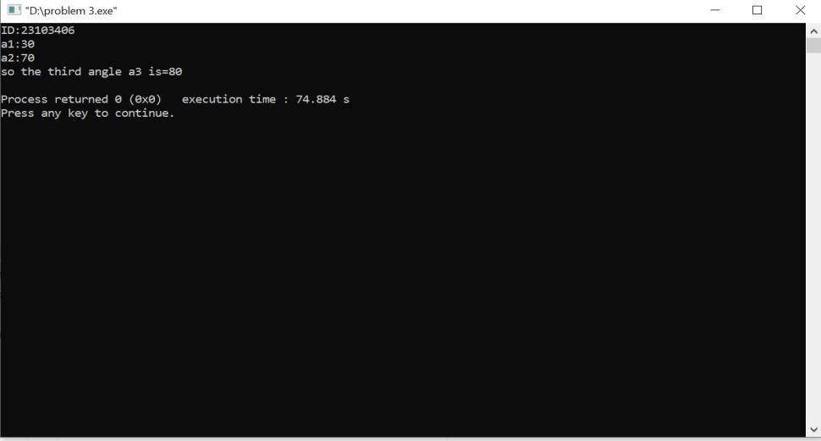

Problem:3
Mr. Rahim lives in a room that has these dimension. Length of room is 24m and width is 13m. If he wants to cover the whole floor with tiles of dimension 1mX1m, write a C program to find out how many tiles are needed to cover the floor.
#include<stdio.h>
main()

{
int l1,l2,w1,w2,area_of_the_room,area_of_tiles;
float tiles_needed;
printf("ID:23103406\n");
l1=24;
w1=13;
l2=1;
w2=1 ;
area_of_the_room=(l1*w1);
printf("area of the room:%d\n",area_of_the_room);
area_of_tiles=(l2*w2);
printf("area of tiles:%d\n",area_of_tiles);
tiles_needed=((float)area_of_the_room/area_of_tiles);
printf("tiles needed=%.3f\n",tiles_needed);}

